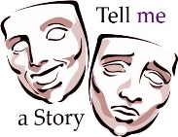

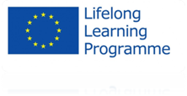

**Project title:** TELL ME a story   
**Programe:** Lifelong Learning Programme  
**Sub-programe:** Grundtvig   
**Action type:** Partnerships 2012   
**Action:** Grundtvig Learning Partnerships

**2nd Newsletter-** TELL ME A STORY Project

The second meeting of the project “Tell Me a Story” took place in Gondomar, Portugal held on 15th to 18th May 2013. The communication tools for a mailing group and internet tools ([grundtv/ig_theatre-project@googlegroups.com](mailto:grundtv/ig_theatre-project@googlegroups.com) | <http://www.tellme.nowadays.pl/about-the-project/>), were useful for the preparation of this meeting. On the other hand, materials/outputs can be found and download.

**The second partners meeting of the Tell Me Project**

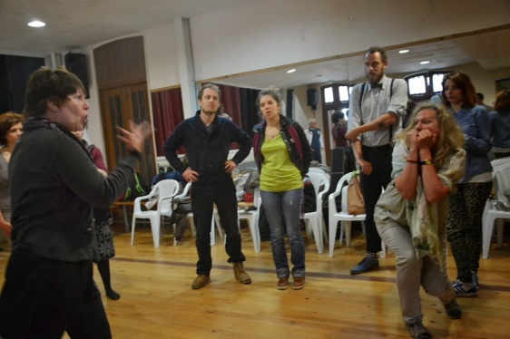This second meeting was attended by the following partners: Poland; Netherlands; Austria; France; and Italy.

During the first part of our meeting there was the reception of the President of the host institution to all European partners as well the presence and performance of traditional Portuguese music performed by senior students of Senior University of Gondomar. Still referring to this part, all participants of all partners participated in the workshop held by the Austrian partner.

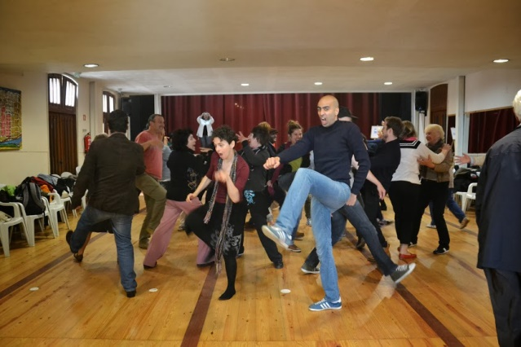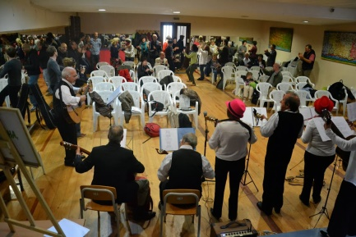In the second part of the meeting, started with the coordinator meeting and the coordinator partner brought out the main idea and goals of the Tell Me Project, the basic method of research (the use of theatrical techniques in adult education) as well the subsequent steps in the project and a few changes were made. Instead of working in tandem we all agree to take a different approach for the activities - workshops.

Still during the second part of our meeting, one workshop was performed by the Holland partner and after that all participants saw the performance achieved by the ALA Nun 'Alvares Amateur Theatre group.

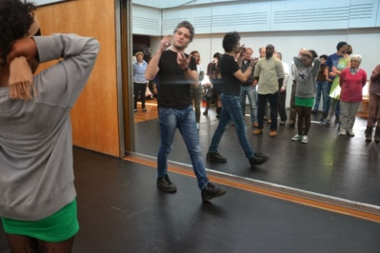

On the last day, after a visit to the port wine cellars and the boat trip on the River Douro, all participants had the opportunity to participate a professional Portuguese Theatre Workshop in S. João National Theatre.

This meeting has been implemented as it was planned and the entire tasks were made. Also the Portuguese partner has already created an intergerational Amateur Theatre group.

This project has been funded with support from the European Commission. This publication [communication] reflects the views only of the author, and the Commission cannot be held responsible for any use which may be made of the information contained therein.