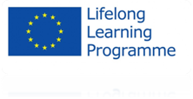
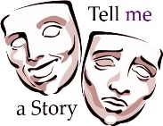
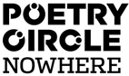

Third Partner Meeting Activity Report

The third partner meeting of the Tell me Project took place in Amsterdam, the Netherlands, on October 9, 10 and 11 2013.

Organizations from the following countries participated in the meeting: Poland, Austria, Italy, Portugal, France and the Netherlands.

Wednesday October 9
- Reception of the partners in ‘Atelier Rozengracht’. Word of Welcome by Poetry Circle Nowhere (Babs Gons, Jorien Waanders) and short cultural program about Amsterdam & the Arts by Neske Beks (theatre and film director) and Harald Vlugt (visual artist)
https://www.facebook.com/media/set/?set=oa.527506084002820&type=1
- Performance by poet/singer songwriter Joost van Kersbergen.

Thursday October 10
- Introduction of the organization NOWHERE by Michel de Rooij (director of NOWHERE) in Studio K (cinema,/theater/club/restaurant).
- Theatre workshop by Polish partner.
- Theatre performance/workshop by Italian partner.
- Musical workshop by French partner.
https://plus.google.com/photos/117508849206482729017/albums/5974352737736591633
- Circle Session: evening full of performances by 15 performers of the Poetry Circle Nowhere in NOWHERE Theatre. https://plus.google.com/photos/101195551273347958361/albums/5980218635825884209

Friday October 11
- Coordinators meeting at Lloyd Hotel.
- Agreement on the dates for the next meeting in Italy: 23-24 May.
- Preparations for the book about myths, theatre and project aims, all partners will write an article (5 pages). Ilona Zakowicz is the final editor and will draft the theoretical part and will coordinate the book. First drafts of the article should be finished by all partners by mid November 2013.
- France coordinator will prepare a proposal for a flyer that all partners can digitally disseminate.

- Cultural city walk and stories by story-teller and city guide Dineke Stam.

