Description of the experience of the partners in the field of theater

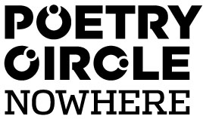
The Poetry Circle Nowhere

The Poetry Circle Nowhere is a group of passionate writing performers who experiments with the boundaries of performance poetry, spoken word and storytelling.
The Poetry Circle comes together on a regular basis to train in writing and performance and to work on plays and performances for theater, clubs, festivals, exhibitions and open spaces. The group gives workshops and collaborates with artists from various disciplines, like theater, writing, visual art, photography and music, both national as international. They work with a variation of directors, theater makers and other artist on shows and performances.
Since its inception in 2008 the Poetry Circle Nowhere has built a repertoire of 6 full theater shows. The shows have been performed in theaters and on festivals in the Netherlands, Belgium and in the United Kingdom (Manchester), as part of an international theatre festival. Besides the theater shows the PCN creates many short performances for all kinds of events.

The Poetry Circle Nowhere exists of six groups in different cities, Amsterdam, Eindhoven, Groningen and Rotterdam and will continue to grow in 2013. The Poetry Circle Nowhere is part of Youth Culture House Nowhere. Nowhere offers workshops, masterclasses and talent classes for children and young adults and offers a stage by organizing festivals and talent nights.
The performers are between the ages of 18 and 35 and come from very diverse backgrounds. Culture, background and language play important roles in the making of performances and play.
The main goal is to bring people together who uses writing as a powerful tool for self-expression. It allows them to express themselves in their own language, and it allows them to address issues that they find important. They tell the stories of the cities, recognizable stories for a large and diverse group of urban young people. Reflecting on small and big things in life, rhyming critically about current events or simply writing a beautiful poem about last night or an ode to love. To refer to the world, to honor poetry, to tackle the bigger political and social issues of life and to bring to the surface the treasure of personal and recognizable experiences.

“Poetry is the unexpected utterance of the soul. Much more than the manipulations of language, it is a necessary art by which we live and breathe.”

~Mark Nepo~

www.poetrycircle.nl

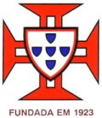

Ala de Nun’Álvares de Gondomar
The ALA Nun' Álvares Gondomar was founded on September 30, 1923. It is an Institution that promotes several activities related with no formal adult education, sport, culture and recreation, located in Gondomar, Portugal. Its objectives are: To provide its members and all comunity the possible means of education, culture and recreation, such as lectures, courses, meetings, Workshops, conferences, music, theater, and others cultural and educational activities.
In 1924 this institution founded their "Schola Cantorum" and later this Group gave rise to a band music.
This Institution is also very involved in cultural activities since 1926. In this year was created the Theater Group, which later gave rise to the current Amateur Theatre of Ala Nun' Alvares de Gondomar, that are an important mean to promote cultural and educational activities in the community.
This Institution has also a Music School, where students could learn how to play several musical instruments, like Guitar, flute, organ and piano.
This institution is also very connected with the learning and the practice of several sports activities, such as the Volleyball, the School of Tennis, a School of Recreational Table Tennis with the aim not only to compete but also to disclose their practice. Related with these activities the Institution also promotes several other activities for the community and their adult learners such as the maintaining gym for ladies, Children's Gymnastics, Jazz Dance, aerobics and maintenance for men, and karate, which came to have a significant number of subscribers.

During the project ALA will create a SOS Portuguese Language Course in order to teach some word and expressions of Portuguese language for all participants. Will be organized a class of Theater where the seniors will learn some interpretation techniques with a professional help from a Professional Young Theater Company. During the classes they will also have lessons about how to use the internet (blog; facebook). Within the project also will be organized a Workshop for all partners about an interactive theater piece based on the exploitation of European Tales and oral tradition in order to promote new methods of interactive learn.
In this project ALA will bring an added value because we have huge experience in the promotion and developing of several educational, cultural and social inclusion activities in local community that could be a good support for the activities related with this project.

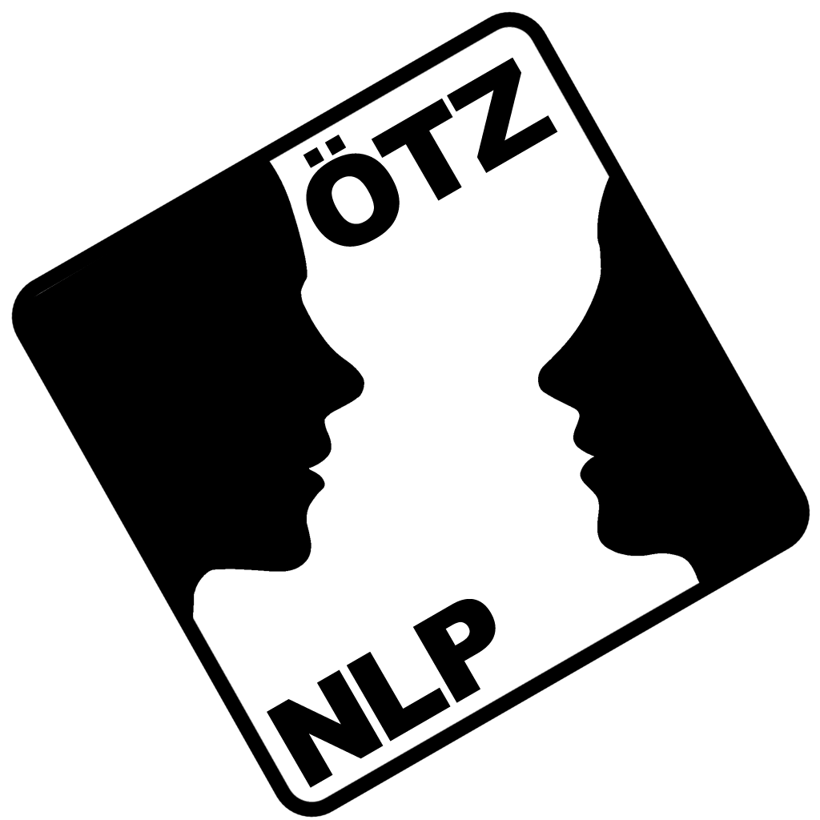
Austrian Training Center for NLP and NLPt
The Academy for Coaching and Psychotherapy
(short: ÖTZ NLP & NLPt)
Experiences in the field of theatre
In the field of NLP-training we concentrate a lot on verbal and non-verbal linguistic patterns (e.g. Milton Model, Meta Model) as well as on body language (e.g. Rapport, Pacing & Leading) and other competencies that are crucial in the field of theatre (e.g. Association – Dissociation, Modeling). Furthermore, in the exams our learners are asked to create and perform theatrical performances.
Kathrin Kienel-Mayer, our project manager for “Tell Me”, brings in different theatre experiences:
- Improvisational theatre (Keith Johnstone)
- Playback Theatre (Jonathan Fox) and RückSpiegelTheater www.rueckspiegeltheater.com)
- Forum Theatre/ Theatre of the Oppressed (Augusto Boal)

- ‘Classical’ role theatre (french dramas from Dubillard, Tardieu, Ribes, Ionesco, Labiche, Marivaux, Maupassant, etc.)
- EU Grundtvig Learning Partnerships with theatrical topics:
CréAction - Create and act towards personal development through theatre in foreign languages (EU Grundtvig Learning Partnership, 2009 – 2011, Partners: Austria – Germany – Norway): The central goal of CréAction was to improve the personal development of learners through theatre techniques in the foreign language. The activities comprised different workshops with the goal to experiment with creative (theatre) methods. In the course of the project, a questionnaire-based study examined theatre methods as appropriate means to improve and facilitate language learning as well as their impact on the personal development. A video film captured the activities at various stages and the results obtained within the partnership.
C’Europe on Stage (EU Grundtvig Learning Partnership, 2007 - 2009): The partner groups explored burning issues of their partner countries and perfomed three Forum Theatre plays (Malta – May 2008, Austria - October 2008, Greece - May 2009). Within the Grundtvig Learning Partnership project “C’Europe on Stage” each partner did research on one burning issue within their culture of origin. Based on this material, a director of a partner country developed a Forum Theatre play. In Forum Theatre (Augusto Boal) the audience plays an essential part, being spect-actors rather then spectators. Each performance included learners from all partner countries – giving a multi-cultural dimension to the work of the directors, while the audience was always local people from the hosting country. All scenes were looked at from the European perspective and emphasised the European dimension and ultimately re-inforced the development of a European identity. (For more information see: www.ceurope-on-stage.net)

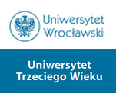 Theatre groups at The University of the Third Age

The Inter-generation Theatre
It’s a theatre group lead by Aleksander Kobylarek. The group consists of both the U3A and regular students of the University of Wroclaw. The aim was to create an opportunity for the elders and the youths to co-operate and, as a result, to create a new, interesting artistic quality. This aim has been achieved. The presentations’ subjects and utilized means of expression differ considerably. The students of theatre classes are not only

actors but also can become directors. During the classes both seniors and youths, who are not professional actors, can refine their skills of how to express themselves using the verbal and non-verbal communication, the body, the emotions. The performances allow their participants to get to know one another, to break the “age buffers”, to get rid of the stereotypes. One of the results of this collaboration is a presentation called “The descendings”.

The Little Theatre of Poetry
It is a dozen of seniors from the University of Third Age in Wrocław, who under the direction of Mrs. Jagoda Jenczelewska create a particular type of plays. The common feature of those performances is poetry, which is recited by the seniors, as well as music, meticulously chosen props and a unique mood accompanying the shows. The Little Theatre of Poetry employs the variety of artistic expression to develop the seniors’ own passions, talents and interests. It inspires a sensitivity for art, integrates and mobilizes to seek interesting forms of artistic expression. The group takes on diverse topics, such as: „Welcome, o Capital, welcome, Warsaw. Wisława Szymborska - the First Lady of Polish poetry”, „Angel spoke to the shepherds” (a Polish carol).

Theatrical project „The kaleidoscope of generations”
It is an intergenerational group, directed by Kacper Chamot and attended by seniors from the University of Third Age, as well as students of the University of Wrocław. The director employs various forms of artistic expression: music, dance, singing, thus creating interesting performances, which unmask and break the stereotypes surrounding age and ageing.
By means of cooperation between generations, a musical entitled „The Lonely House” was created, as well as the play „In between” and the vernissage „In the Kaleidoscope of Generations 2”.

